Debates by topic
Find some partners to work with (ideally a group of four students)
Go to idebate.org and click on DEBATEBASE

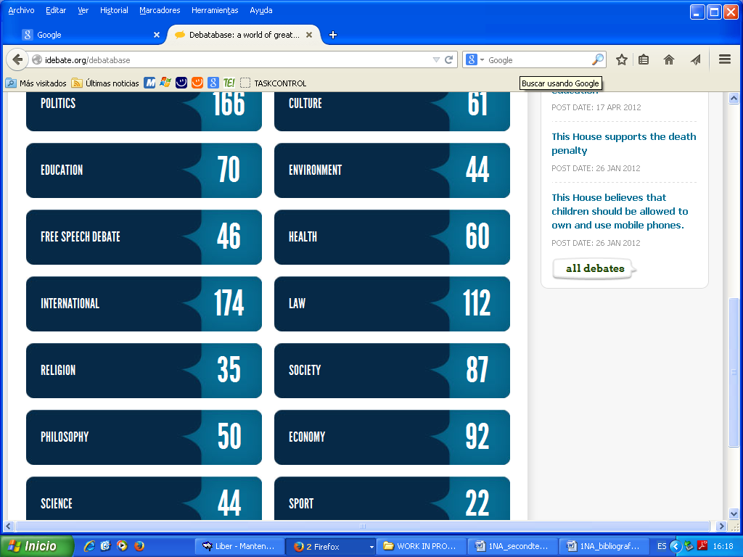

It might be a good idea to check with your classmates what theme/motion they are going to work on to avoid repetition.
Choose one of the themes
Choose one of the motions
e.g. This House believes that the traditional university will be replaced by online learning
Before you look at the points for and points against summary, try to find 2 or 3 ideas in favour and against the motion by yourselves
Book a day to make your debate presentation in class

