KEY
Simple past and past progressive
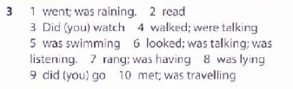
Correct or not 1
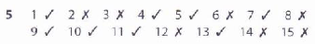
Correct or not 2
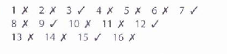
Correct the mistakes
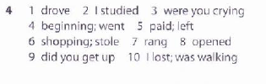
Grammar in a text
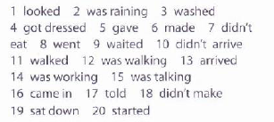
Don’t do the exercise Simple past or past perfect
Grammar in a text
