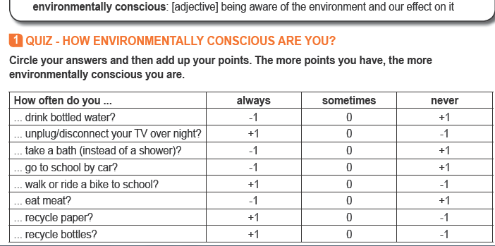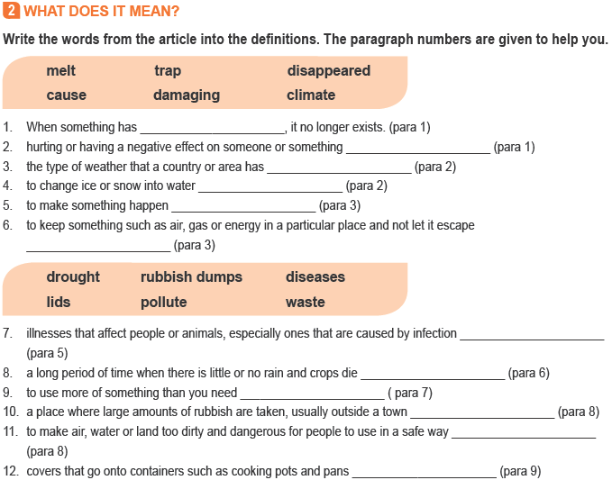

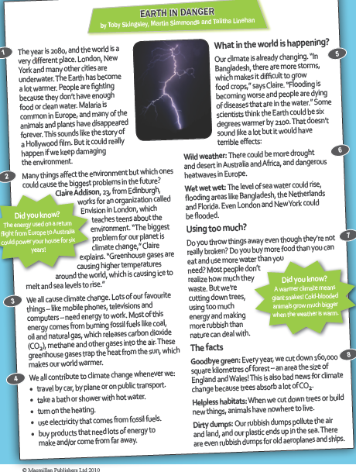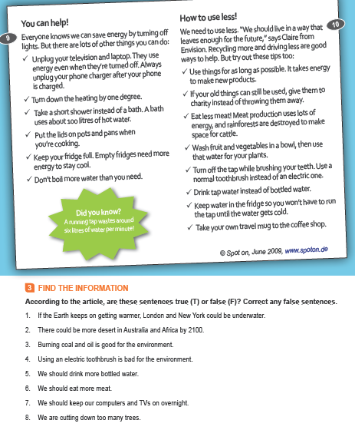
Our impact on nature is called our ‘ecological footprint’. To find out what your footprint is, go to http://footprint.wwf.org.uk/?_ga=1.29594623.1971871331.1489401816
and do the online test. Do you want to find out how to reduce it? Click here or follow the link below
http://footprint.wwf.org.uk/tips

